Bandit Level 1
DG Interns Hub | Week 1 | OverTheWire Bandit Writeup

Objective
Read the password stored in the home directory.

Activity summary
Suggested learning command / approach: cat readme. Use only on the authorized OverTheWire training environment.

Key learning
Reading files using cat.

Evidence
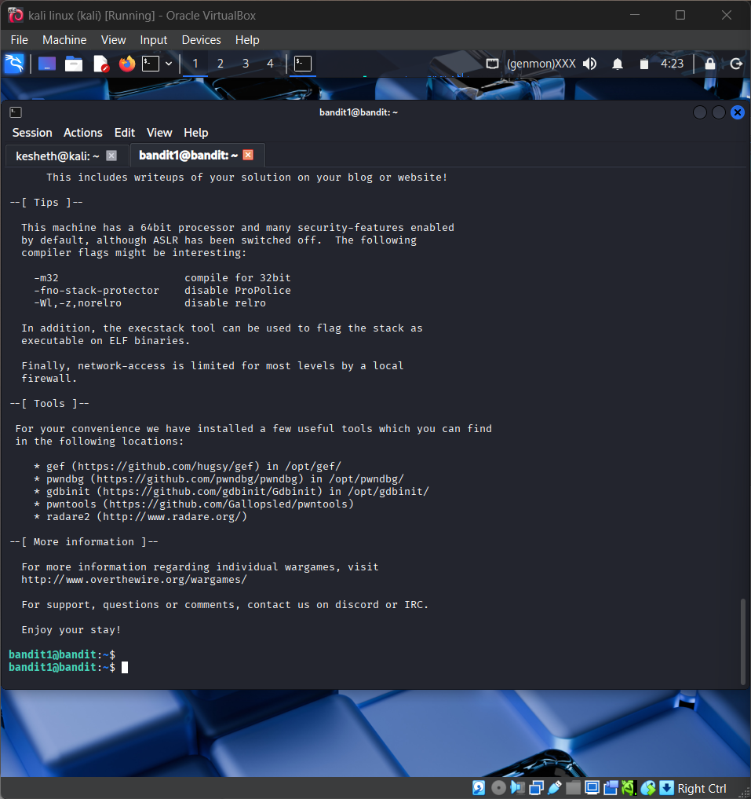
Screenshot: Bandit_Level_1.png
The screenshot is evidence of level activity/login; it may not show every solution step. No passwords are reproduced.

